End-to-End Retail Performance and Behavioral Analytics

1. Introduction
In the modern retail landscape, staying competitive requires more than just high sales volumes; it requires a deep understanding of customer behavior and operational efficiency. With the rise of multi-channel shopping (Online vs. Physical), businesses are flooded with data that often remains siloed.
This project was developed to bridge the gap between raw transactional data and strategic decision-making. By integrating sales, product, and customer demographics, the project provides a 360-degree view of business health, helping stakeholders move away from intuition and toward data-driven growth.

2. Problem Statement
- Customer Retention & Churn: Identifying which customers are likely to stop purchasing is difficult without a defined behavioral metric.
- Product Profitability: High sales volume doesn't always equal high profit; understanding the relationship between discounts and margins is critical.
- Channel Performance: Businesses struggle to see if their physical stores are losing ground to online channels or if they complement each other.
- Return Impact: High return rates can bleed profits; identifying "problem products" is essential for inventory optimization.

3. Project Objectives
To solve these problems, I set out to achieve the following:
- Analyze Behavioral Trends: Define and track "Customer Churn" based on a 90-day inactivity window.
- Visualize Financial Health: Create dynamic KPIs for Total Revenue, Profit Margins, and Return Rates.
- Optimize Regional Sales: Identify top-performing cities and regions to guide future store expansions.
- Customer Segmentation: Categorize the customer base into Loyalty Tiers to personalize marketing efforts.
4. Dataset Overview
The analysis is based on a relational dataset consisting of five core tables:
- Sales: Transactional records (Order ID, Date, Channel, Revenue, Profit).
- Products: Item details (Category, Brand, Cost, Unit Price).
- Customers: Demographic data (Gender, Age, Region, Signup Date).
- Stores: Physical location data (City, Region, Operating Cost).
- Returns: Records of reversed transactions and reasons for return.

5. Technical Workflow: Step-by-Step Process
Step 1: Python Data Cleaning & Exploratory Analysis (EDA)
Using Python (Pandas), I audited the raw CSV files to handle missing values and duplicates.
- Handling Nulls: Identified and handled missing values using df.isnull().sum().
- Data Consistency: Standardized gender labels and cleaned store names.
- Feature Engineering: Created age_group (e.g., 18-30, 31-45) and margin_pct columns to enable deeper demographic and financial segmentation.
- EDA: Generated distribution plots for sales across categories to identify initial "Revenue Pillars."
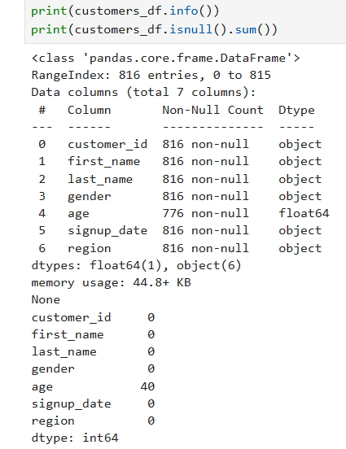
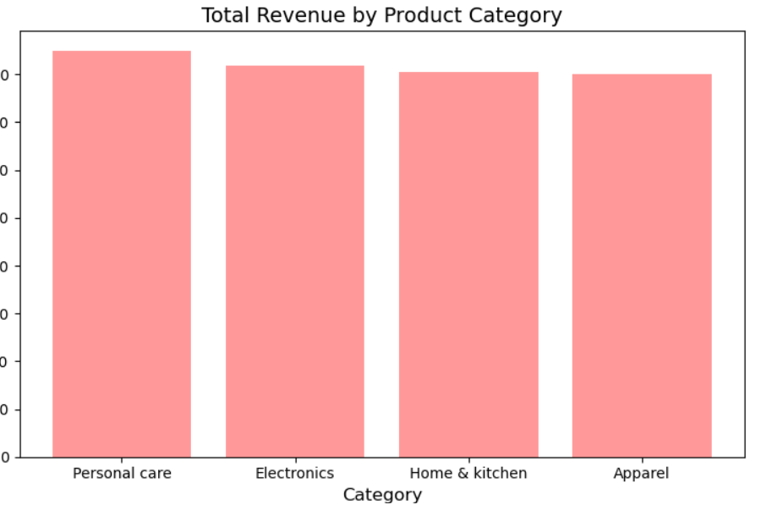

Step 2: Database Schema & SQL Foundations
I migrated the cleaned CSVs into SQL Server to build a structured relational environment (RetailNova_DB).
- Schema Design: Created tables with defined Primary Keys (e.g., customer_id) and Foreign Keys to enforce referential integrity.
- Date Formatting: Used SET DATEFORMAT dmy to prevent errors during time-series analysis.

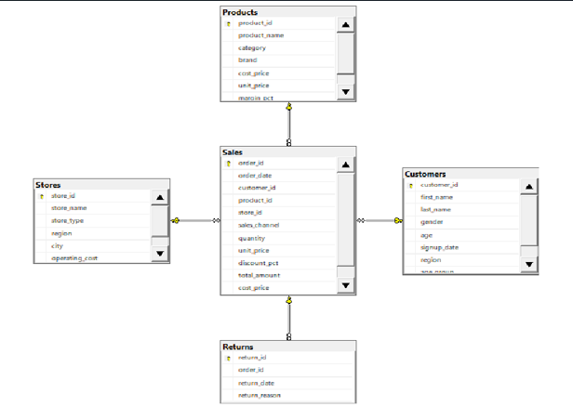
Step 3: Answering Business Questions (SQL)
After building the relational schema in SQL Server, I executed complex queries to extract deep business insights. Below are the results and explanations for each of the 10 critical business questions.
1. What is the total revenue generated in the last 12 months?
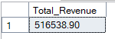
2. Which are the top 5 best-selling products by quantity?
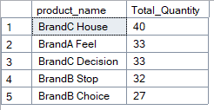
3. How many customers are from each region?
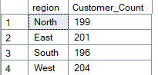
4. Which store has the highest profit in the past year?
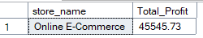
5. What is the return rate by product category?
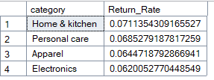
6. Average revenue per customer by age group?
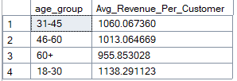
7. Which sales channel (Online vs In-Store) is more profitable on average?
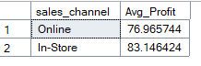
8. Monthly profit change over the last 2 years by region?
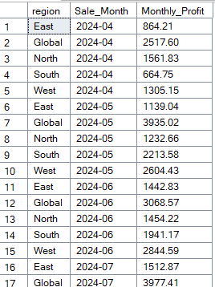
9. Top 3 products with the highest return rate in each category?
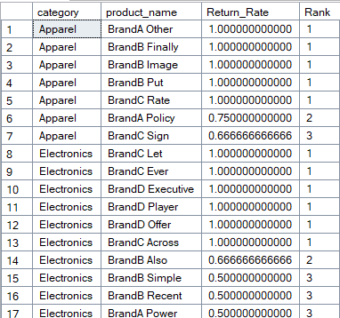
10. Which 5 customers have contributed the most to total profit, and what is their tenure with the company?
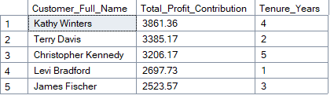

Step 4: Power BI Data Modeling
I connected Power BI to the SQL database and designed a Star Schema model.
- The Model: Sales acts as the central Fact table, connected to Customers, Products, Stores, and Calendar Dimension tables.
- Efficiency: This model allows for lightning-fast cross-filtering across all 5 dashboard pages.
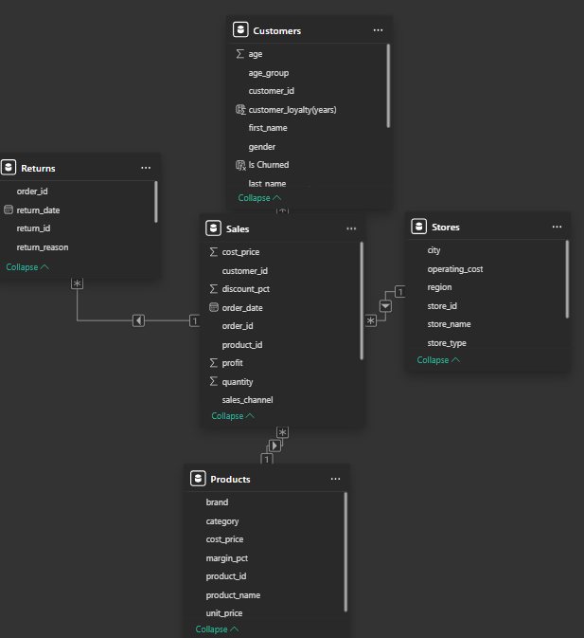
Step 5: DAX Measure Development & Dashboarding
I developed advanced DAX measures to enable behavioral tracking:
- Churn Rate %: A custom measure to identify customers inactive for >90 days (accounting for those who "Never Purchased").
- Page Layout:
  - Sales Performance: Overall Revenue, Profit, and Order Trends.
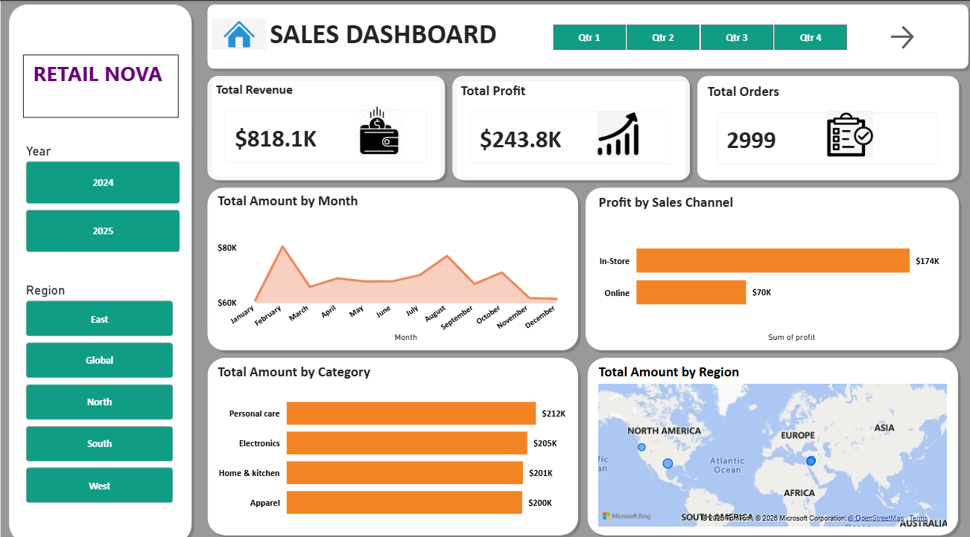
  - Customer Insights: Gender split, Loyalty Tiers, and Churn KPI.
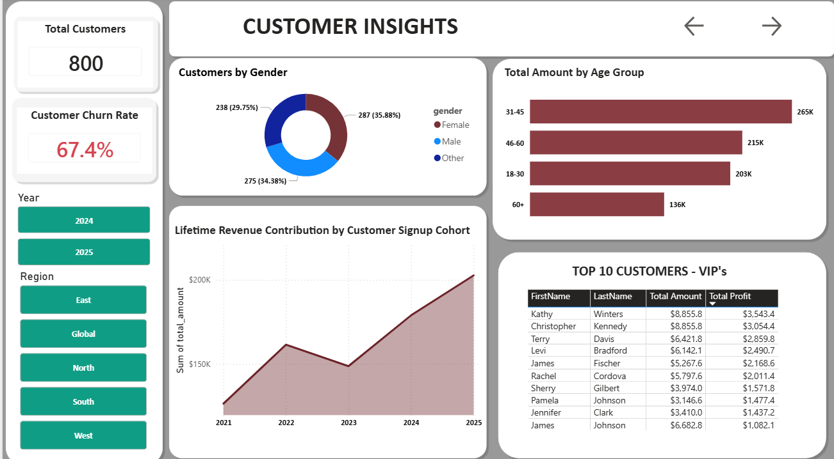
  - Product Performance: Category and Brand analysis.
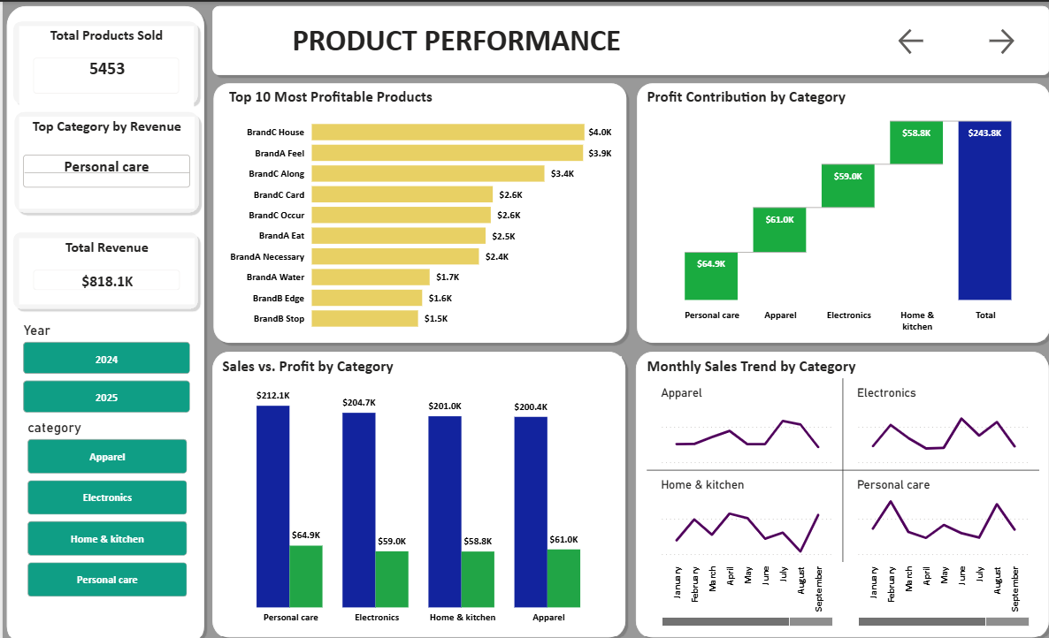
  - Return Analysis: Financial impact of defective or wrong items.
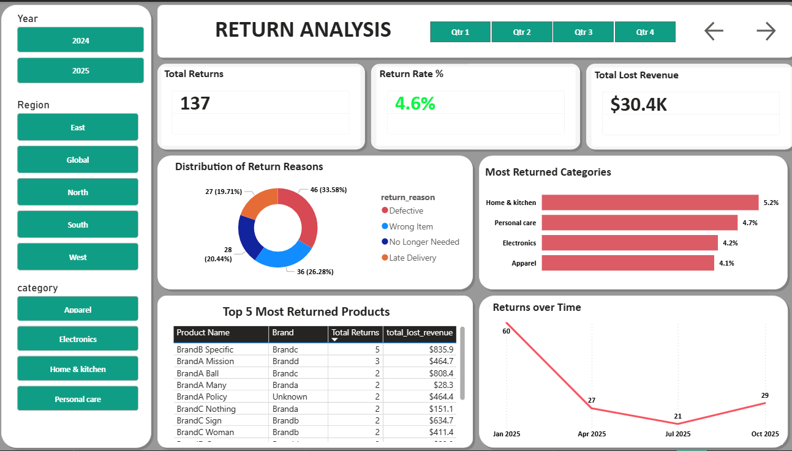
  - Store Performance: Regional maps and Channel comparison (Online vs. Store).
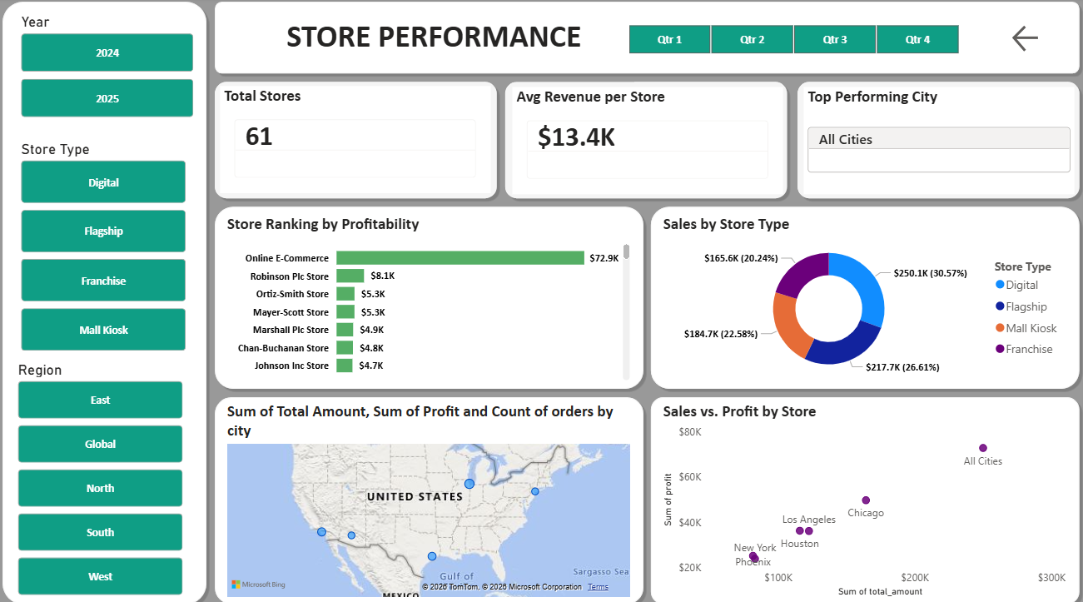

6. Key Insights & Findings
- Churn Reality: A significant portion of churned customers are those who signed up but never completed a first purchase.
- Product Risk: Specific "Electronics" items have a 15%+ return rate due to "Defects," impacting category profitability.
- Regional Growth: The "South" region shows the highest average profit per transaction, making it a prime candidate for a new flagship store.

7. Strategic Recommendations
- Conversion Focus: Implement a "First Purchase" coupon for new signups to reduce the "Never Purchased" churn segment.
- Return Mitigation: Audit suppliers for products identified in the SQL DENSE_RANK analysis as having high return rates.
- Loyalty Personalization: Target the "Gold" loyalty tier with region-specific offers based on the Store Performance map.

8. Author Info
- Name: Sara Mahesh
- Role: Data Analyst
- Contact: saramahesh01gmail.com

